### Video Portal Deployment Guide

#### Video Portal Site Design Setup

Solution deployment scripts are in the following folders of the “ITSOLNCF.ShareRealization” Project:

* “Deployment/VideoPortal”

Before running deployments scripts, please make configuration adjustments in the

{Deployment/ VideoPortal} VideoPortalSitesConfig.json

* **askCredentials** – true or false. Prompt for user credentials or get them from the file
* **username** – user name. Will be used if askCredentials = false
* **password** – user password. Will be used if askCredentials = false
* **tenantUrl** – URL of the tenant
* **sharePointAdminUrl** – SharePoint administrator portal URL
* **environment** – environment name (DEV,QA,UAT,PROD)

{Deployment/ VideoPortal/PROD} VideoPortal-script-joinToHub.json

* **hubSiteId** – a video portal hub site id

{Deployment/ VideoPortal/PROD}VideoPortal-script-pageFooterExtension.json

* **title**: "SharePageFooter"
* **location**: "ClientSideExtension.ApplicationCustomizer"
* **clientSideComponentId**: SharePageFooter component id
* **clientSideComponentProperties**: "{\"OwnersInternalName\":\"ALFA_PageOwners\", \"EditorsInternalName\":\"ALFA_PageEditors\"}"
* **scope**: "Web"

To start the video portal site design deployment, please run “AddVideoPortalSiteDesign.ps1” script, it creates sited design namely “AlfaLaval design -  Video Portal site” in Alfa Laval tenant.

Once the site design is created, then create a test communication site and apply the site design to make sure all the required settings are in place with the site design.

After site design testing is completed start the video portal runbook deployment in Azure Portal.

Make sure a video portal site template should be uploaded in the site assets library in the portal landing site

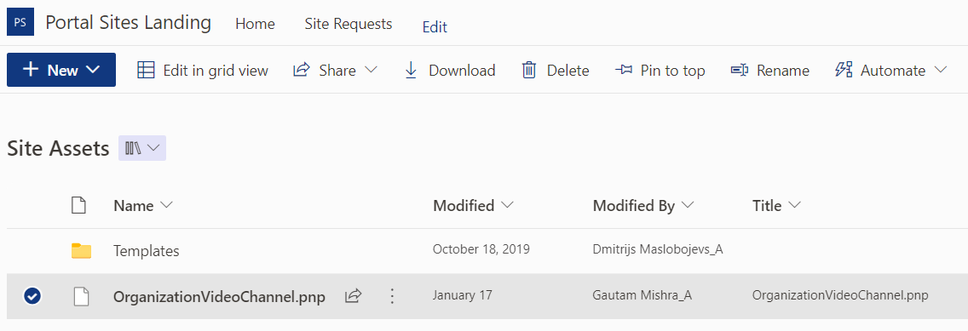

#### Video Portal Runbook Setup

To deploy the video portal runbook in Azure Portal, follow the below setups.

1. Login into Azure Portal <https://portal.azure.com/>
2. In the left-hand menu, select "Automation accounts" and then select the Automation account you want to use or create a new one with the following information.

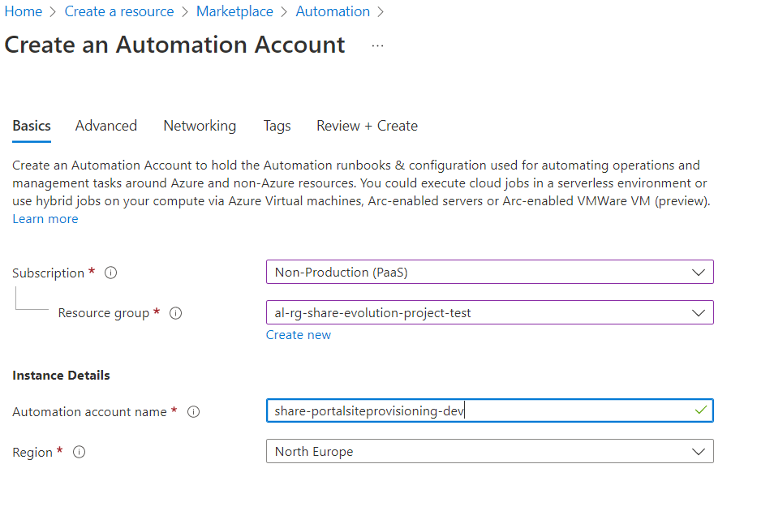

1. In the Automation account blade, select "Certificates" in the left-hand menu and add the certificate as shown below.

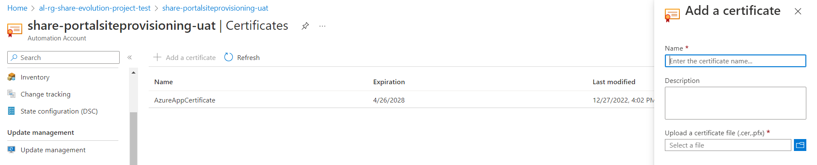

1. Then in the Automation account blade, select "Credentials" in the left-hand menu and add the credentials as follow.

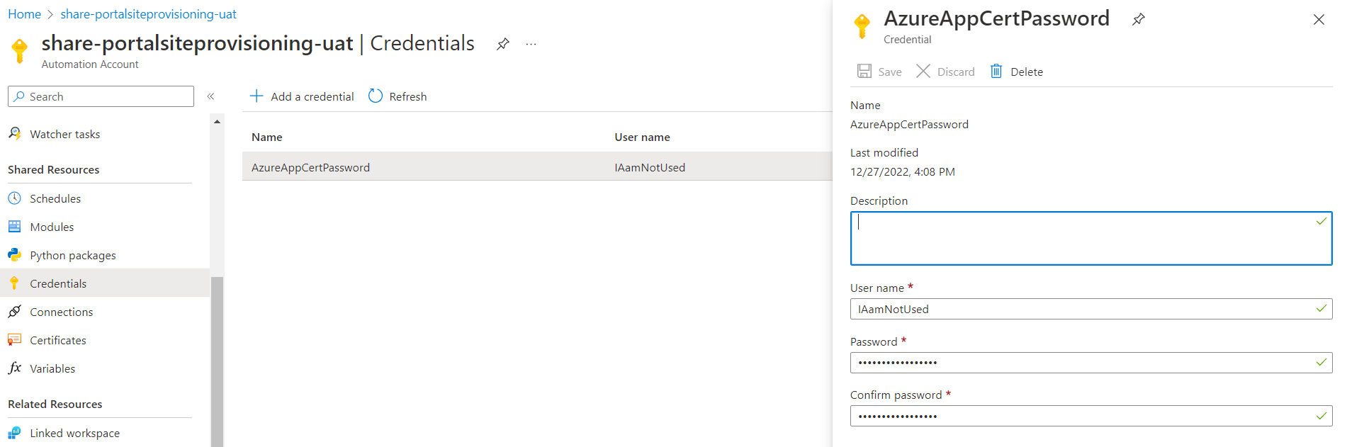

1. After Credentials creation is complete then create the required variables for the runbook as shown below.

1. Once the initial setup is completed then click on the “Runbooks” in the left-hand menu.
2. Select the "+Create a runbook" button at the top of the page.
3. On the "Create a runbook" page, enter a name for the runbook and select the type of runbook you want to create.

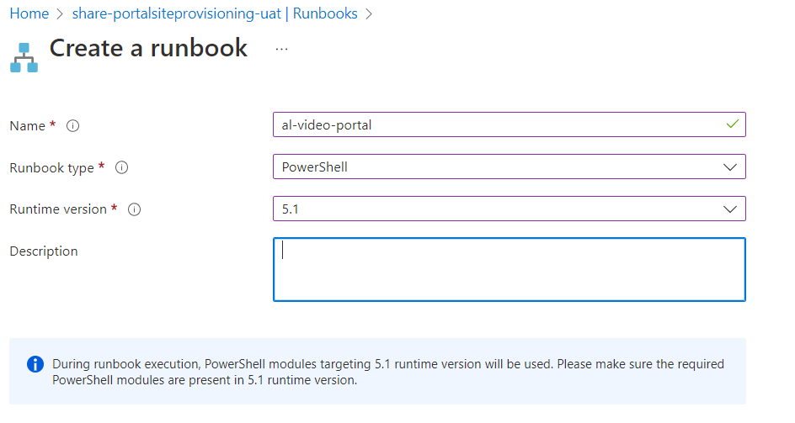

1. In the Runbook editor, you can write your PowerShell script, or you can import a script from a local file or from a source control repository.
2. Once your script is complete, save the runbook and then select "Publish" to make it available for use.
3. You can then test the runbook by clicking on the "Test" button or schedule the runbook by clicking the "Schedule" button.
4. Once you have tested and scheduled the runbook, it will be ready for use.

#### Video Portal Runbook Testing

1. Navigate to the Portal Landing site “(https://alfalavalonline.sharepoint.com/sites/portalsitelanding) and submit a portal site request for the "Organization Video Channel" type as shown below.

1. Once the site request is created an approval email will trigger to Business Owner, Once Business Owner approved the request the site request entry turn into approved.
2. Scheduler will pick the Approved site request with the site type “Organization Video Channel” and it will create a site.